DISCOVERED ATTACK

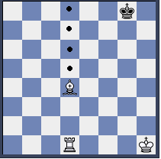
The Rook and the Bishop are on the same file. If the Bishop on d4 is played, then the Rook suddently attacks the squares with a dot. These squares are attacked indirectly. The Bishop must find a target to make a double attack possible. That results in an attack with Rook and Bishop.
This double attack with two pieces of the same colour is called a discovered attack.

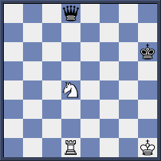
In a discovered attack, two pieces attacking simultaneously are important: the front and the back piece form a battery. In a discovered attack the front piece is fired first. After Nd4-f5 the Knight attacks the King and the Rook the Queen.
A double attack on King + material.

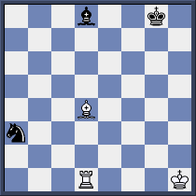
The second type of attack is similar to the other double attack: material + material. By playing 1.Bd4-c5 White Rook the Bishop with the Rook and the Knight with the Bishop.
Not a good discovered attack is 1.Bd4-b2. Black rescues his Bishop and Knight with the move 1…Bd8-e7.
A double attack on material + material.

The third type of attack is material + square.
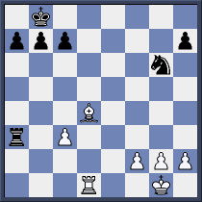
The battery is aimed now on an important square. On d8 the White Rook can give mate, but at the moment the Bishop is in the way. The Bishop must attack the Rook with the move 1.Bd4-c5. The back pice threatens mate.
A double attack on: material + square.

